NEWS from MEXICO
AUGUST 1, 2014

We’ve had a busy month! It is so exciting working for the Lord. And YOU play a part in all of this… Without your prayers and support we couldn’t do any of this!
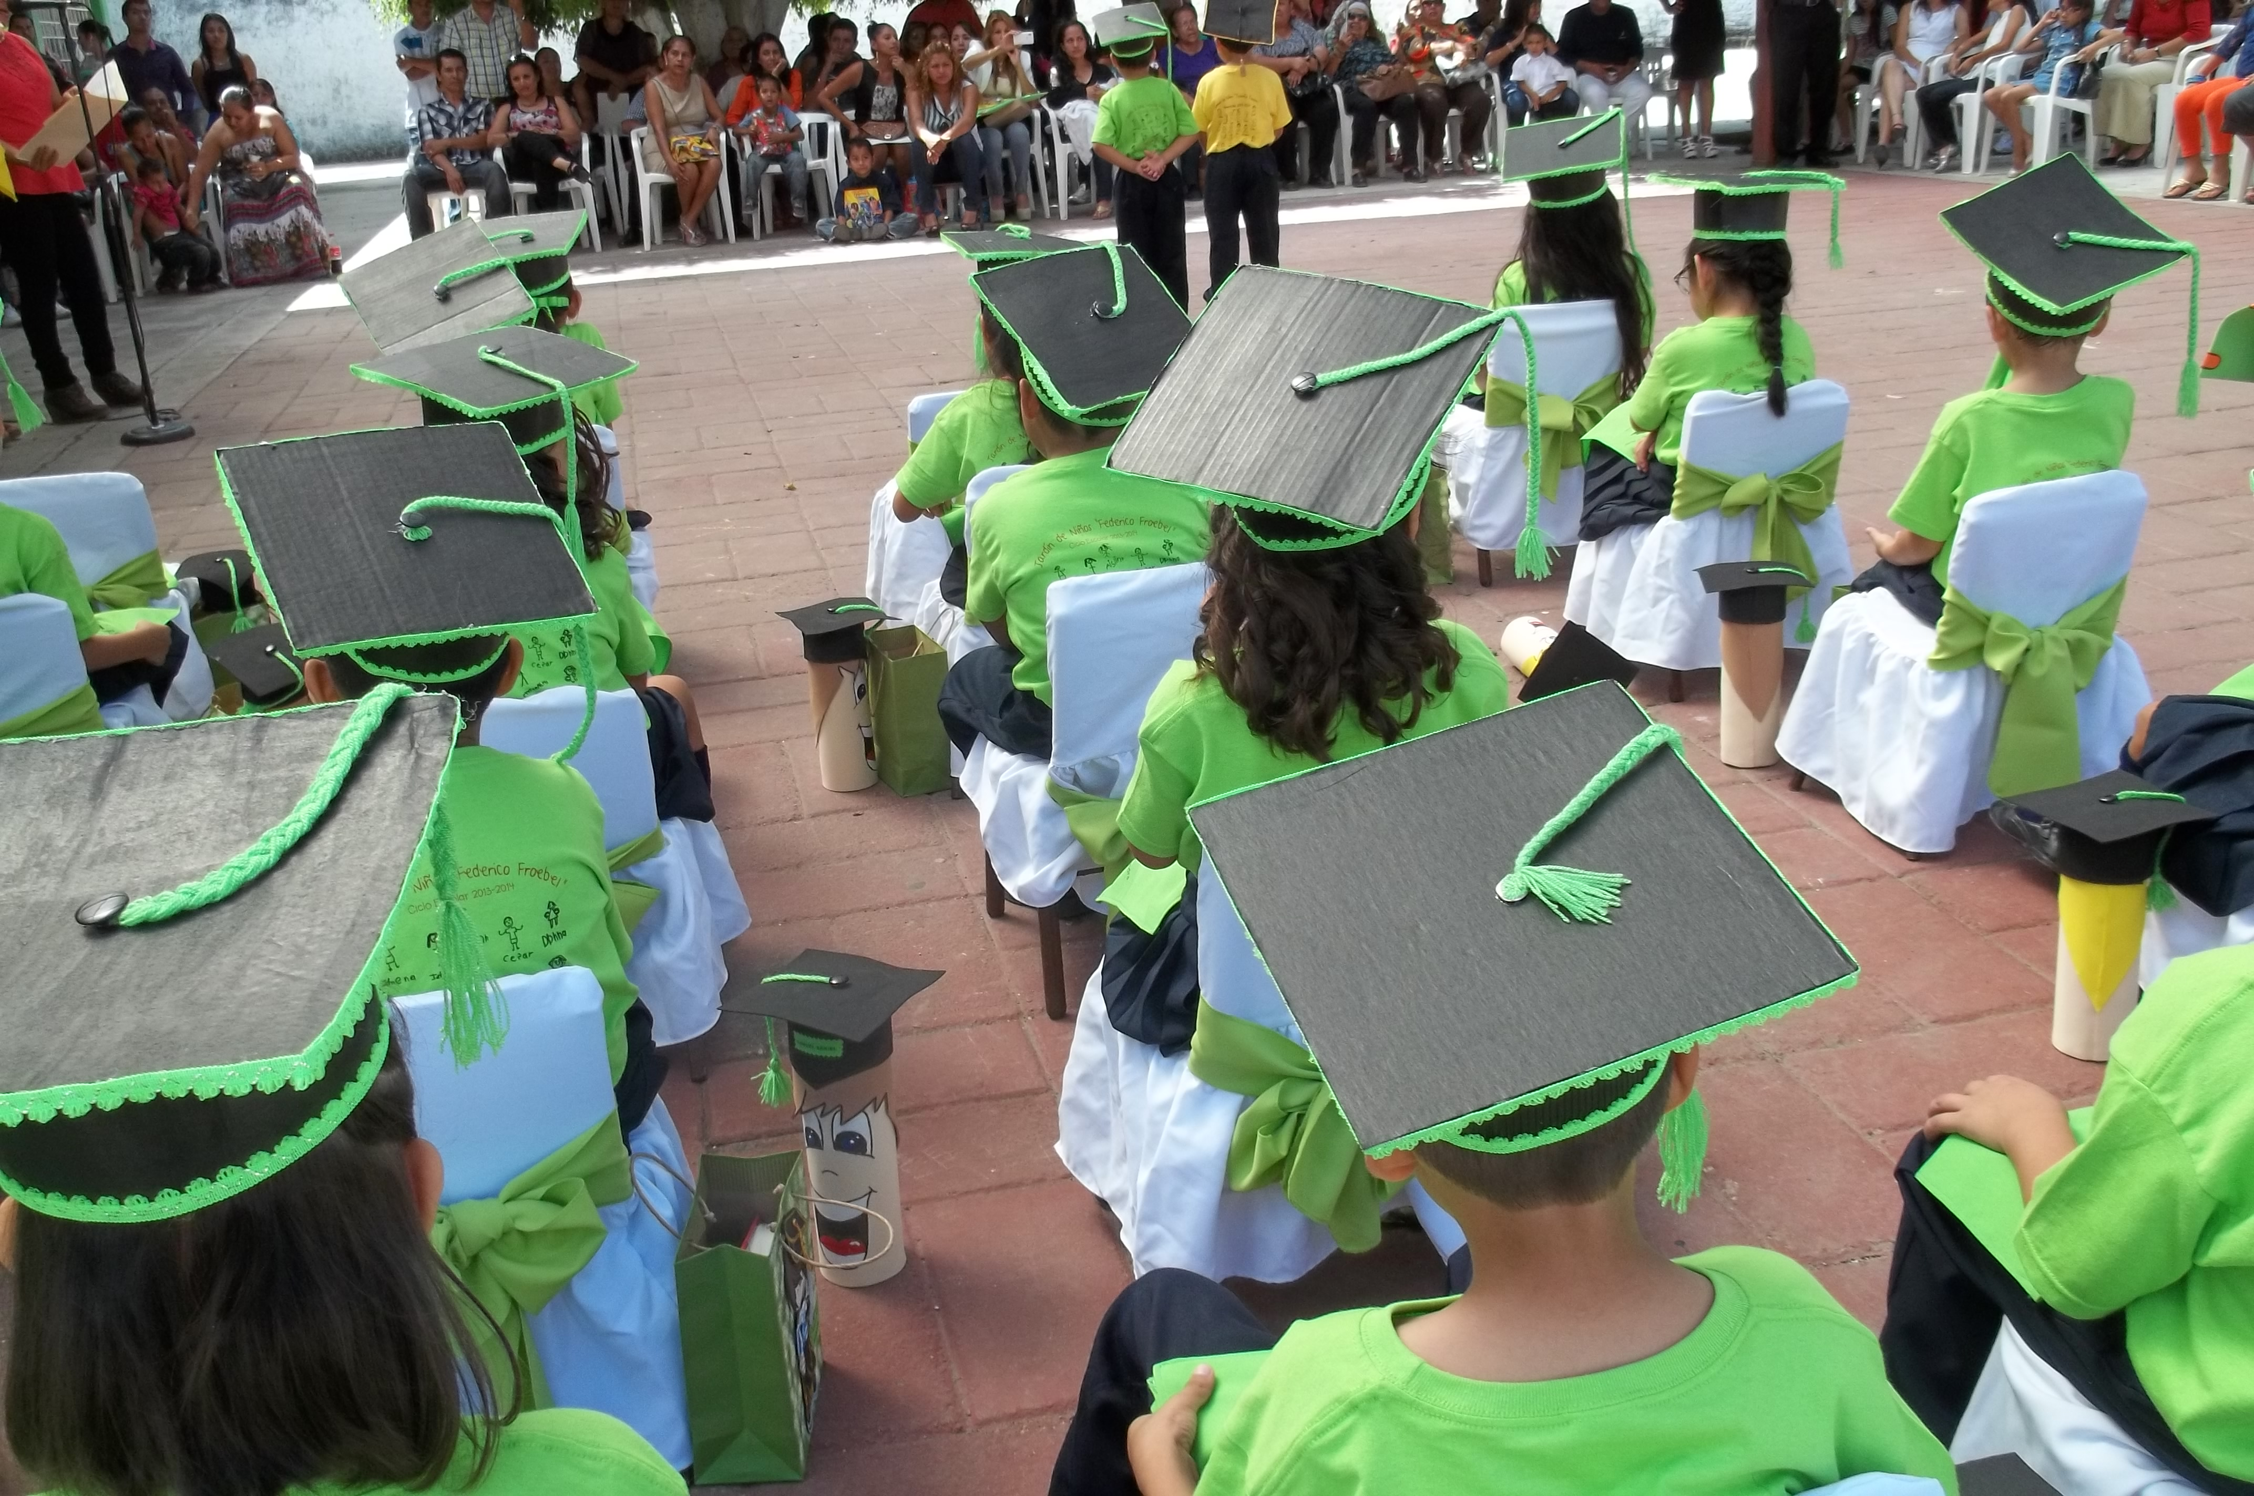
We got home to Tepic on the 4th of July! Giving me time to attend the Kinder Graduation! All the Children were so excited to see me return. This group is now off to 1st grade in August. The Director has asked me to come back then to continue teaching English. So mid-month I’ll begin English at the Kinder and at the Casa de Niño’s!
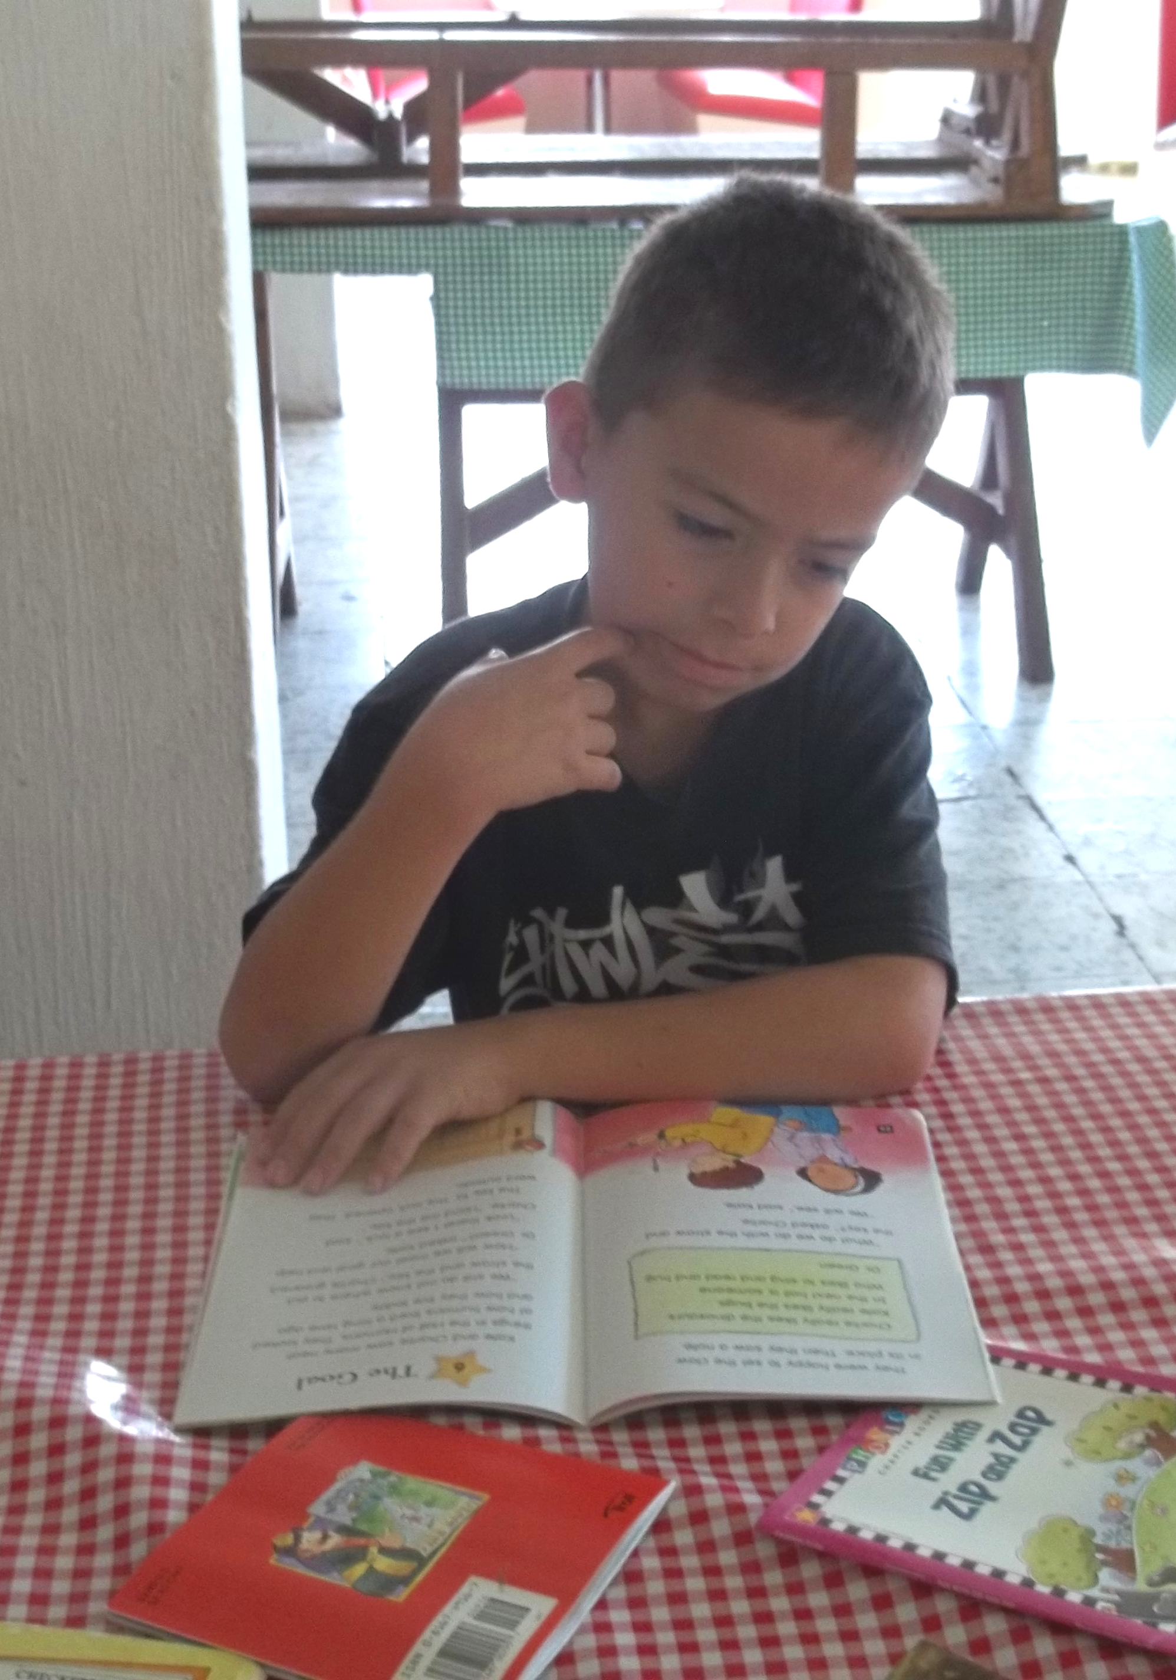

Speaking of Casa de Niños, We are back full swing…Mike has already mowed the yard several times and we’ve been up there playing with the kids too. We were given a big box of books this trip and we are putting them to use as a “Library Day” with the kids!
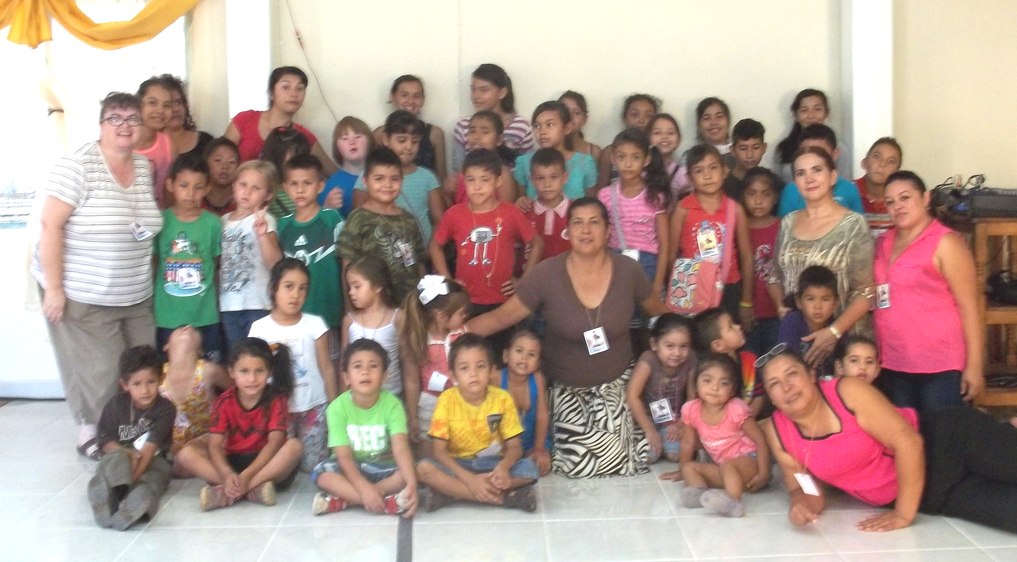


Our first VBS was at Iglesias Cristiana Bendita Unción, where we had over 40 kids with 14 of the children coming forward to receive Jesus as their Savior!

Mike has been in the prison every Wednesday since we got back. Not only are the inmates in his groups happy to have him back, so are the guards! This past weekend he was at the Laguna at a Men’s Retreat with Pastor Tony and Bendita Unción.

I also want you to know that we are preparing to cut back on our snail mail to be better stewards of our funds. If we have your email we will be using it. If however you still want to receive it by snail mail, just let us know and we’ll send it no problem.

Thank you for your continued prayers and support! Until next month!!
Remember to Keep C.O.O.L. (Christ Over Our Lives!)

Mike and Becky

